**IST 659 LAB Assignment NO -6**

1. Find out all flight schedule information of flight “3310” and “3312”. Make sure to show all the fields.

**Query:**

/*all the flight schedule information about flight number 3310 and 3312*/

SELECT *

FROM FLIGHTSCHEDULE_table

WHERE flightNumber IN (3310 ,3312)

**Result:**

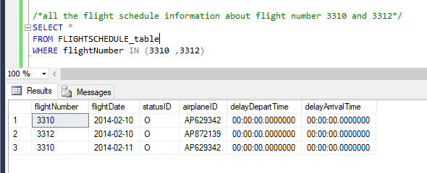

1. Find all flights departing from airports that start with ‘S’. Show flight number, depart airport, arrival airport, and depart time.

**Query:**

/*all flights departing from airports that start with ‘S’*/

SELECT flightNumber, departAirport, arriveAirport, scheduledDepartTime

from FLIGHTROUTE_table

WHERE departAirport like 'S%';

**Result:**

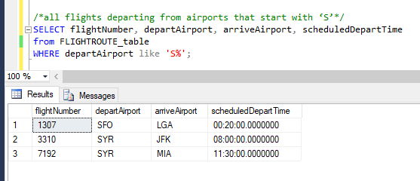

1. Find 4 most recently purchased planes. Show airplane ID and purchase date only.

**Query:**

/*4 most recently purchased planes*/

select top 4 airplaneID, purchaseDate

from AIRPLANE_table

order by purchaseDate DESC;

**Result:**

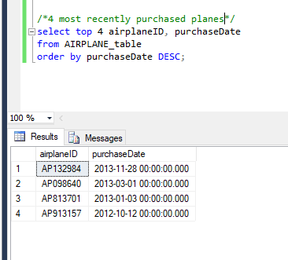

1. Count the number of flights departing each day. Show the date and the number of flights.

**Query:**

/* Count the number of flights departing each day*/

select flightDate, count(flightNumber)'number of flights'

from FLIGHTSCHEDULE_table

group by flightDate;

**Result:**

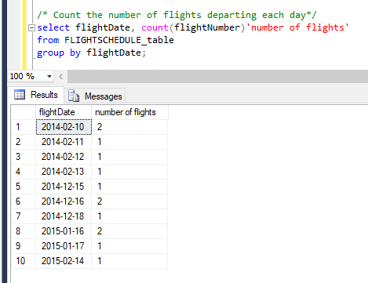

1. Sort the AircraftSpecs table by fuel capacity in descending order. Show the result with

aircraft version and fuel capacity.

**Query:**

/* Sorting the AircraftSpecs table by fuel capacity in descending order*/

select aircraftVersion, fuelCapacity

from AIRCRAFTSPECS_table

order by fuelCapacity DESC;

**Result:**

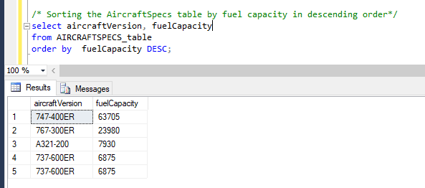

1. Find all airplanes which flew in the first half of Feb 2014 (From Feb 1- to Feb 14) and the flight status was “on time”. Show airplane ID, purchase date, flight number, and status ID.

**Query:**

/*all airplanes which flew in the first half of Feb 2014 (From Feb 1- to Feb 14) and the flight status was “on time*/

Select AIRPLANE_table.airplaneID, AIRPLANE_table.purchaseDate, FLIGHTSCHEDULE_table.flightNumber, FLIGHTSCHEDULE_table.statusID

from FLIGHTSCHEDULE_table LEFT JOIN AIRPLANE_table ON FLIGHTSCHEDULE_table.airplaneID= AIRPLANE_table.airplaneID

where flightDate between '2014-02-01' and '2014-02-14' and statusID='O';

**Result:**

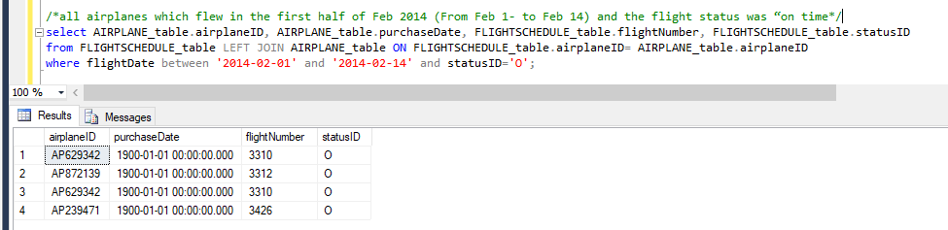

1. Find all flights which depart from “BOS” after noon. Show flight number, flight date, depart airport and scheduled depart time.

**Query:**

/*all flights which depart from “BOS” after noon*/

select FLIGHTROUTE_table.flightNumber, FLIGHTSCHEDULE_table.flightDate,FLIGHTROUTE_table.departAirport, FLIGHTROUTE_table.scheduledDepartTime

FROM FLIGHTROUTE_table LEFT JOIN FLIGHTSCHEDULE_table ON FLIGHTROUTE_table.flightNumber= FLIGHTSCHEDULE_table.flightNumber

where FLIGHTROUTE_table.departAirport = 'BOS' and FLIGHTROUTE_table.scheduledDepartTime > '12:00:00.0000000';

**Result:**

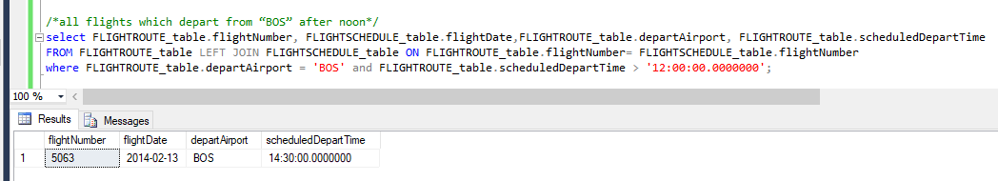

1. Find all airplanes which were delayed or cancelled. Show only airplane ID, flight date and status description.

**Query:**

/*all airplanes which were delayed or cancelled*/

SELECT FLIGHTSCHEDULE_table.airplaneID, FLIGHTSCHEDULE_table.flightDate, FLIGHTSTATUS_table.description

FROM FLIGHTSCHEDULE_table LEFT JOIN FLIGHTSTATUS_table ON FLIGHTSCHEDULE_table.statusID= FLIGHTSTATUS_table.statusID

where FLIGHTSCHEDULE_table.statusID IN ('C','D');

**Result:**

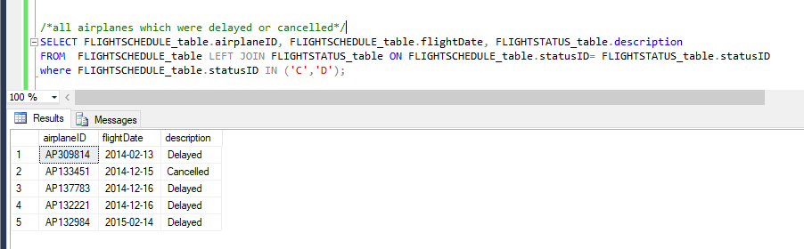

1. Find the flight(s) which are “on time”, display the Flight number and departure airport

**Query:**

/*the flight(s) which are “on time”*/

select FLIGHTSCHEDULE_table.flightNumber, FLIGHTROUTE_table.departAirport

from FLIGHTSCHEDULE_table LEFT JOIN FLIGHTROUTE_table ON FLIGHTSCHEDULE_table.flightNumber= FLIGHTROUTE_table.flightNumber

where statusID= 'O';

**Result:**

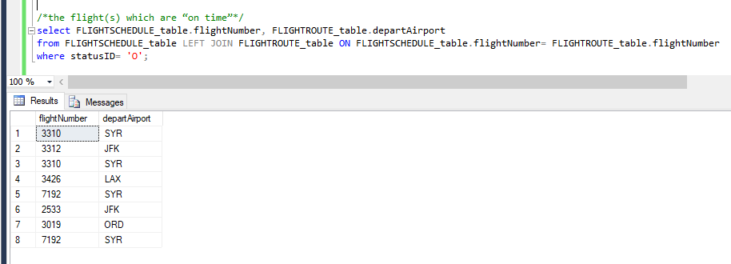

1. Find all the airplanes that have not been scheduled to fly. (You can use Left Join)

**Query:**

/*all the airplanes that have not been scheduled to fly*/

select DISTINCT airplaneID from FLIGHTSCHEDULE_table

left join FLIGHTROUTE_table

on FLIGHTSCHEDULE_table.flightNumber NOT IN ( FLIGHTROUTE_table.flightNumber)

**Result:**

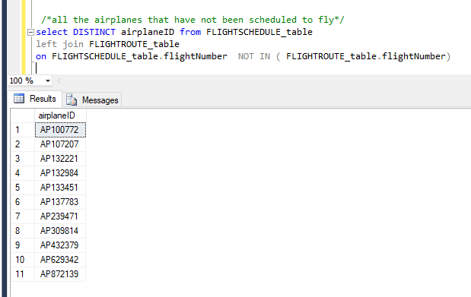

1. Find all only airplanes that have been scheduled to fly and delayed. Display Airplane ID of the flight (Use Right Join)

**Query:**

/*all only airplanes that have been scheduled to fly and delayed. Display Airplane ID of the flight*/

select DISTINCT airplaneID from FLIGHTSCHEDULE_table

right join FLIGHTROUTE_table

on FLIGHTROUTE_table.flightNumber IN (FLIGHTSCHEDULE_table.flightNumber)

where statusID='D'

**Result:**

